**[Classification c1,] "*O*utside cOver reuse"**

<DisplayName> **Outside cOver reuse** </DisplayName>

<KeyboardShortcut> **O** </KeyboardShortcut>

<DirectoryName> **Outside_Cover_Reuse** </DirectoryName>

<AddedFilenameEnding> **orc** </AddedFilenameEnding>

Front cover, back cover, spine, all three. The text/decoration/illumination is visible on the outside cover surface is visible through from the other side. It must be on the codex/book. Limp vellum covers OK, but not wrappers.

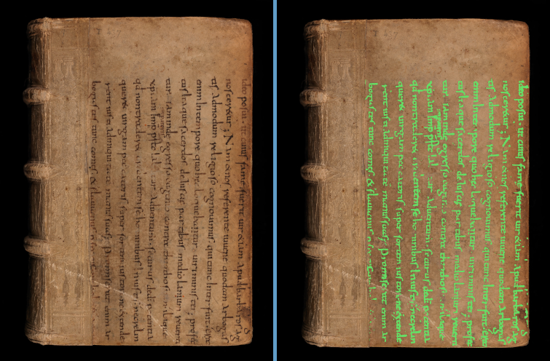

**BaselUniversitatsbib_-_Le-VI-12_00001**

**Heidelberg_-_ salVII73__ z4_00249**

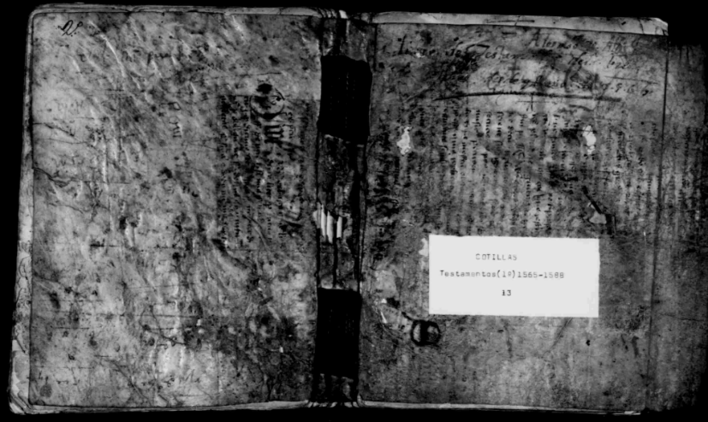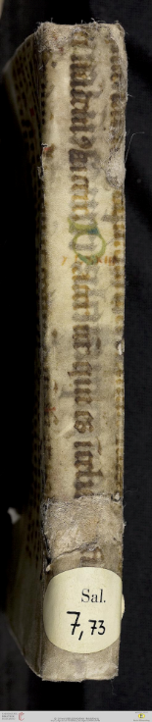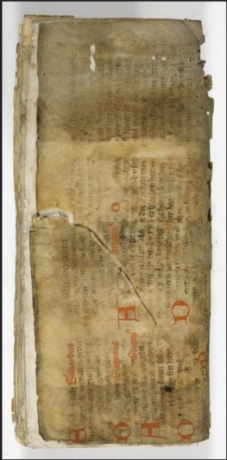

Heidelberg_-_

salVII73__

z4_00249

**FamilySearch_-_DGS004090639_00701**

m _-_HVM? (or KV. ?)

Ba,berg+=+JV<Msc359_00073 Final verdict: **Bamberg_-_HVMsc359_00073**

Bamberg_-_HVM(M)sc359_00073 or Bamberg_-_KV.Msc359_00073

**[Classification c2,] "unde*R* coveR Reuse"**

<DisplayName> **undeR coveR Reuse** </DisplayName>

<KeyboardShortcut> **R** </KeyboardShortcut>

<DirectoryName> **Under_Cover_Reuse** </DirectoryName>

<AddedFilenameEnding> **ucr** </AddedFilenameEnding>

A tear or hole reveals some reuse under the cover or under the paste-down. If it can be determined that this is really reuse protecting the spine, use 's**P**ine Protection reuse'. It is okay to use both of those *for the same piece of reuse*, as long as you DON’T use 'multiple **B**inding reuse classes'. However, if there is such an unsure piece as well as *another* instance of reuse, *do* use 'multiple **B**inding reuse classes' along with the classification(s) of the other class(es). Also, even though I named it 'unde**R** coveR Reuse', holes in the paste-down that show human

signs/symbols/drawings are also classified as '**R**'.

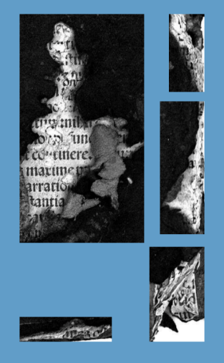

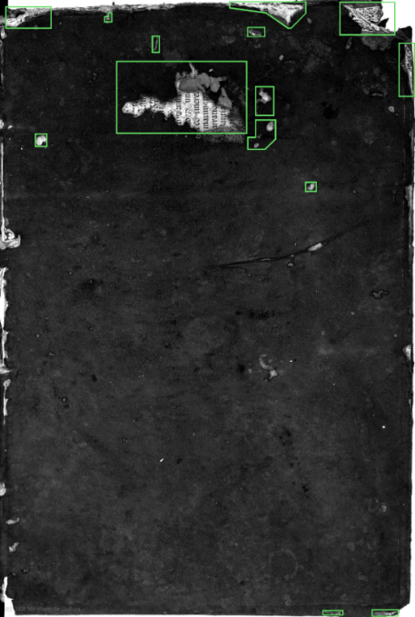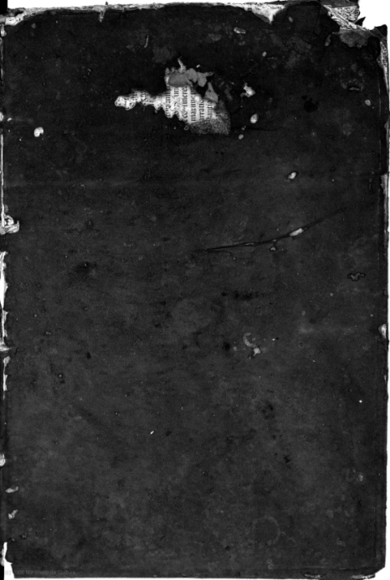

**FamilySearch_-_DGS008279842_00131**

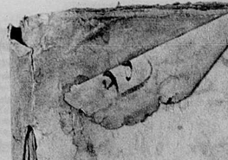

**BVPG_-_BibCastillaLaMancha_-_MarcoAurelio_BPE-Toledo-Signatura-16356_00001**

Multiple pieces of paper, probably stacked to make the cover thick, have ↗ FS-8279842_131

writing visible through the front-cover’s material that appears black here. These unpeeled,

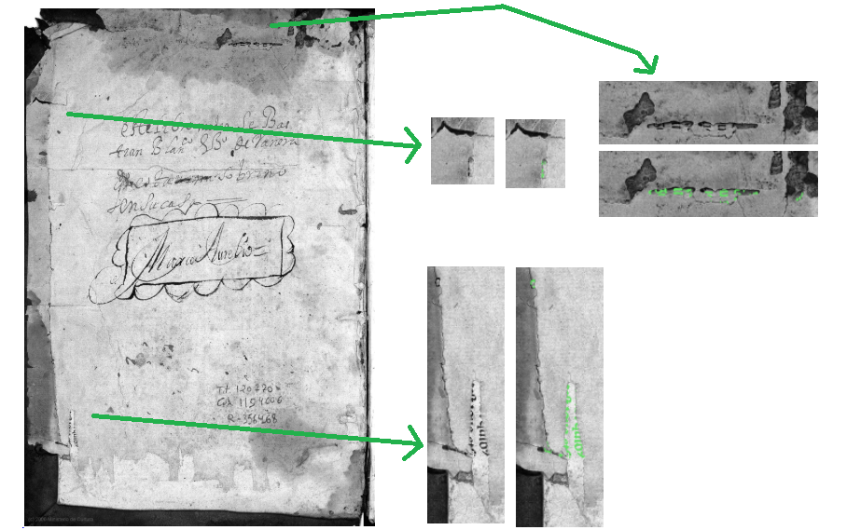 folded back

portions (of what could be ORC if not

folded) are now UCR (as-of-2025-05-05)

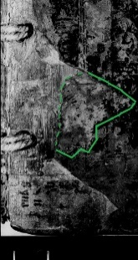 ↘

FS-7996631-676

Here, we see an example of '**R**' being seen through the front paste-down.

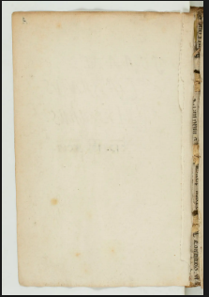

**FamilySearch_-_DGS007996631_00676**

**????**

Text visible

thru & behind

broken book gutters are now, by exe- **BVPG_-_BibCastillaLaMancha_-_MarcoAurelio_BPE-Toledo-Signatura-16356_00002** cutive choice, being classified as '**R**',

*unless* it’s apparent '**P**' (top/bttm).

**[Classification c3,] "s*P*ine Protection reuse"**

<DisplayName> **sPine Protection reuse** </DisplayName>

<KeyboardShortcut> **P** </KeyboardShortcut>

<DirectoryName> **Spine_Protection_Reuse** </DirectoryName>

<AddedFilenameEnding> **spr** </AddedFilenameEnding>

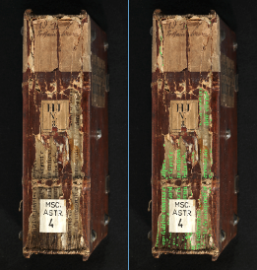A fragment is reused to protect the spine. In some cases, it also goes around to protect part of the covers; however, if it can be seen as part of a paste-down or flyleaf, do not classify it as 'sPine Protection reuse' *unless* the image of the surface is meant specifically to show the spine. If it can be seen as part of a paste-down or flyleaf and is not part of a spine image, it should be labeled 'Front-back matter reuse'.

*Note that these first two surface views are two different views of the same codex.*

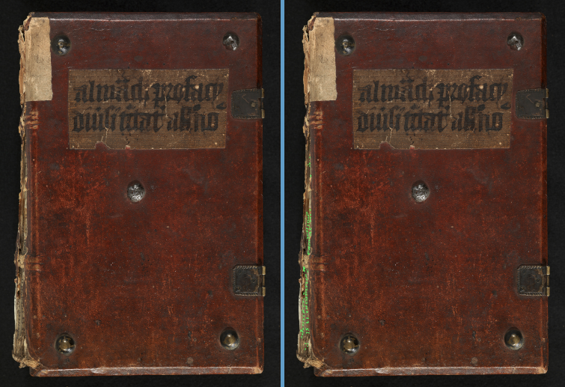**Bamberg_-_MscAst4_00002**

**Bamberg_-_MscAst4_00438**

**??????**

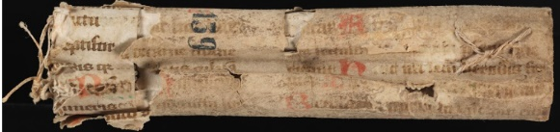

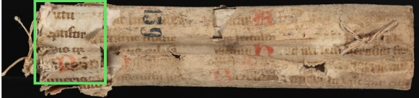

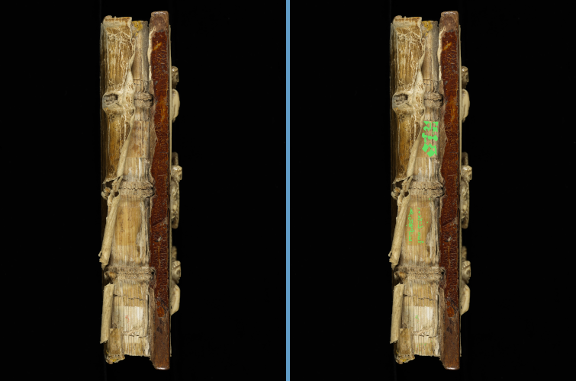

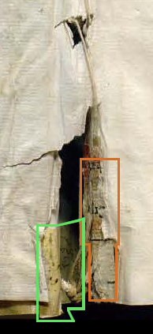

**BnE_-_Mss11453_00002**



BnE_-_Mss11453_00002_augmented-doctored

(I overlaid text on that more-yellowish part

that is protecting the spine.)

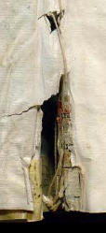

Spine protection (notice position on bottom,

highlighted in green). Also '**R**' in orange.

**BeromunsterStiftskircheStMichael_-_Epistolar-ecod_028** ~~in orange~~

**[Classification c4,] "*F*ront-back matter reuse"**

<DisplayName> **Front-back matter reuse** </DisplayName>

<KeyboardShortcut> **F** </KeyboardShortcut>

<DirectoryName> **Front-back_Matter_Reuse** </DirectoryName>

<AddedFilenameEnding> **fmr** </AddedFilenameEnding>

A fragment is reused as a paste-down or as a flyleaf. We aren’t differentiating paste-down from flyleaf.

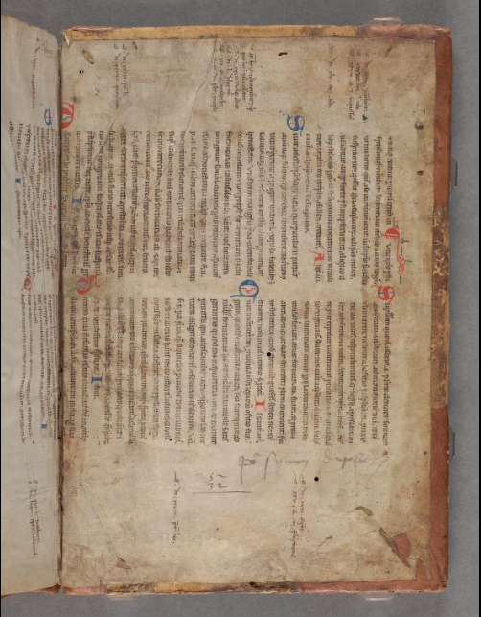

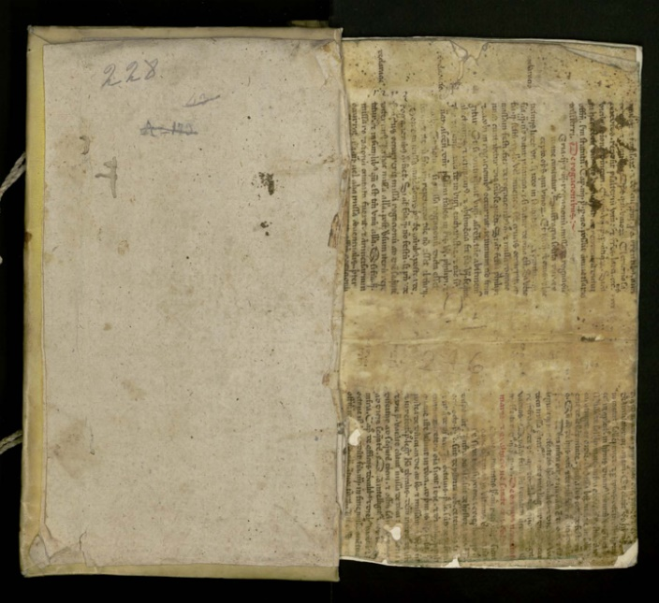**BnE_-_AuroraPierreDeRiga_Mss238_00002**

**LOC_-_MarcoPolo_gdcwdl-wdl-14300_00211**

The page on the right is what used to be a paste-down (look at

the edges closely) but is now a flyleaf. We don’t differentiate, so

the class is the same. Paper with “228” is the current paste-down. Back paste-down (also across-book-gutter

'Front-back matter reuse').

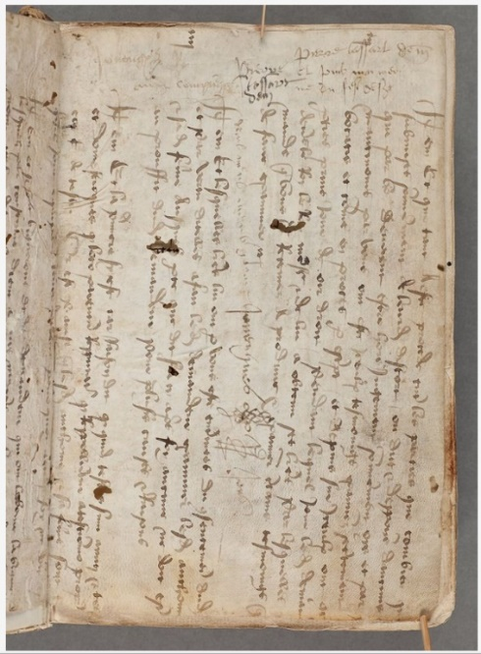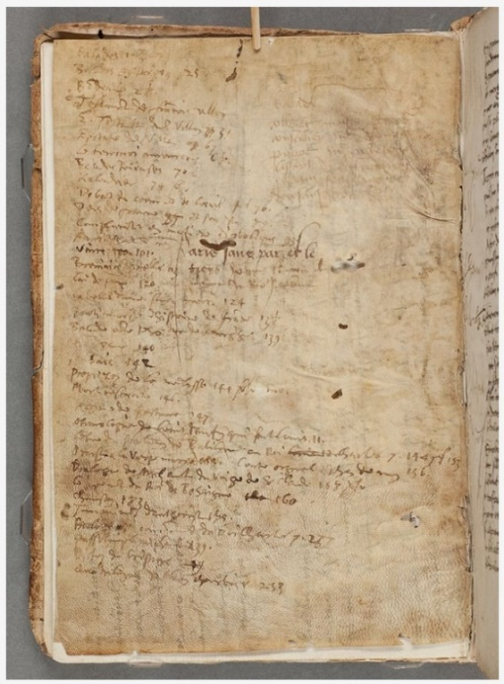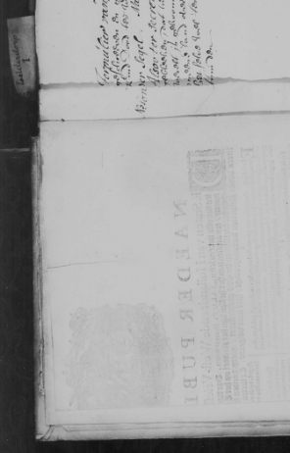

(↓ Image rotated 90° CCW)

**FamilySearch_-_DGS005850144_00018**

**LOC_-_LivreDePlusieursChoses_wdl-14-30-1** **LOC_-_LivreDePlusieursChoses_wdl-14-30-1**

Another visible-from-the-

Front flyleaf – recto. The verso Front flyleaf – verso. It receives the other-side paste-down or

will be shown in the next image classification even though you only see flyleaf. Since we don’t

(to the right). through to the reused text. differentiate, no worries!

**[Classification c6,] "cover *W*raparound reuse"**

<DisplayName> **cover Wraparound reuse** </DisplayName>

<KeyboardShortcut> **W** </KeyboardShortcut>

<DirectoryName> **Cover_Wraparound_Reuse** </DirectoryName>

<AddedFilenameEnding> **cwa** </AddedFilenameEnding>

It’s wraparound – 'cover Wraparound reuse' – if you can see the inside edge of the wraparound, i.e. at least one point. Otherwise, it’s 'Tiny background reuse'. If you’re unsure

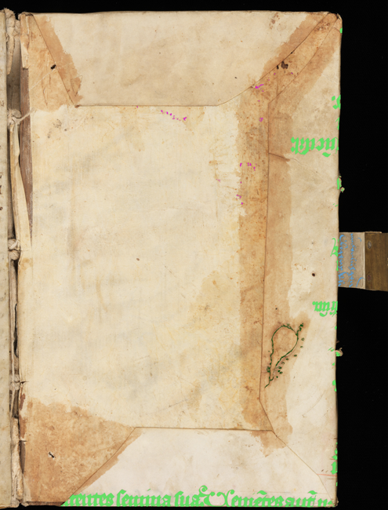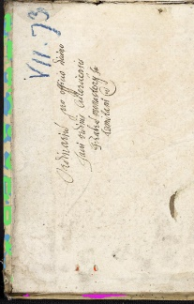I’d suggest '**T**'.

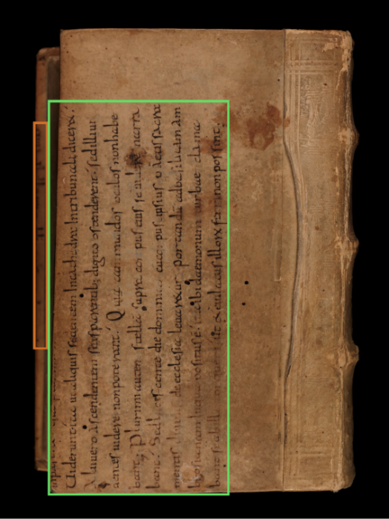

**Heidelberg_-_salVII73__z4_0000**

No need for it to be small

('**O**' in bright green, light-

blue, and maroon). Also '**U**'

(red), so '**B**', too.

**BaselUniversitatsbib_-_Le-VI-12_00004** (part img. rotated CCW.) **StGallenStiftsbib_-_CodSang635-ecod_012**

The wraparound or tiny bkg is highlighted

Look for the **†** in '**T**' (tbr) for some ruling info

In orange, choose '**T**' over '**O**', use '**B**', too.

The wraparound is highlighted in bright green.

There is also '**F**'(maroon), '**C**' (light-blue), and

some stitching (dark-green). You’ll need '**B**', too.

**FamilySearch_-_DGS008289838_01060**

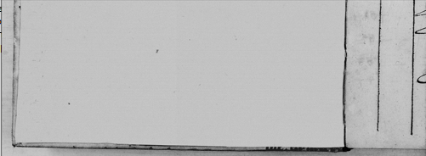

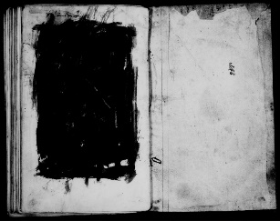**FamilySearch_-_DGS008012433_00513**



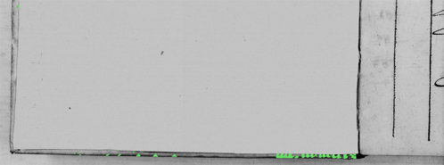

Notice the visible edge of the wraparound. There

are also a couple of manicules (which aren’t being

labeled now) on the left-hand page.

**Cologny_-_CodBodmer99-ecod_017**

On head/tail like this considered '**W**'. (part image, These can be small and hard to see, but they are arguably the

rotated.) most important for finding new and otherwise unseen fragments.

**[Classification c7,] "*T*iny background reuse"**

<DisplayName> **Tiny background reuse** </DisplayName>

<KeyboardShortcut> **T** </KeyboardShortcut>

<DirectoryName> **Tiny_Background_Reuse** </DirectoryName>

<AddedFilenameEnding> **tbr** </AddedFilenameEnding>

It’s basically wraparound reuse or Front-back matter reuse that’s visible when one is reading in the book. It’s when you can see the wraparound, but not the inside edge. There are pages in between where you’re looking from and where the edge reuse is found (either before “what you’ve read” or after – I know you probably haven’t been reading the codex, but I feel it’s the clearest way to explain things). These are small and difficult to find, but I consider them the most important class, because they’ll allow us to find codices where the main reuse hasn’t been imaged. Knowing about the cases will allow us to contact archives, etc. to ask for access to the codex and see the reuse.

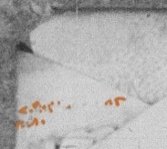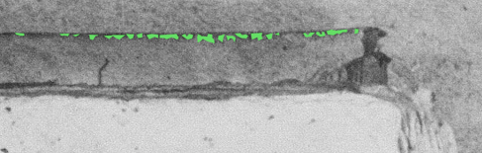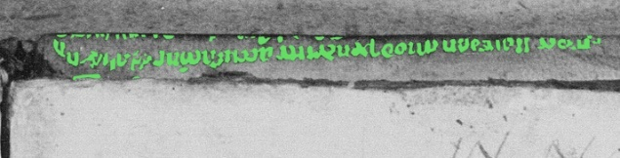

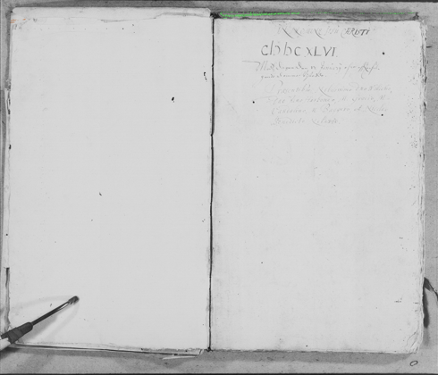

**FamilySearch_-_DGS004534287_00361**

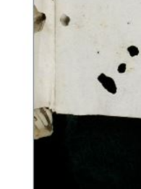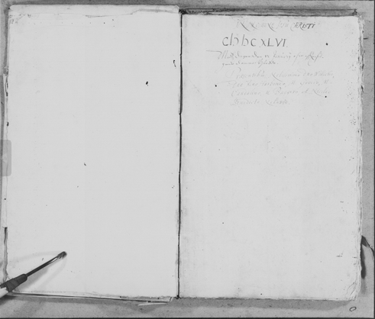

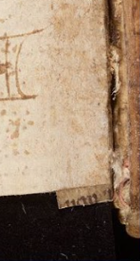 (L) **Bodl_-_BodleianLib_MsHamilton52_00264**

(R) **ZurichZentralbib_-_MsD176C-ecod_00003**

This can be tiny and tricky. On the left

is '**C**', but on the right is '**T**'; as

with '**T**'&'**W**' cases, if unsure betw.

'**T**'&'**C**', use '**T**'. (part imgs.)

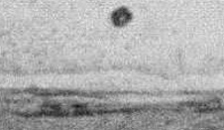This is some nice '**T**' (green). **zLOC_-_MarcoPolo_gdcwdl-wdl-14300_00114**

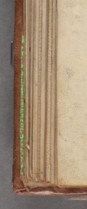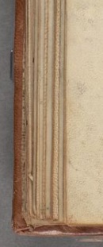I’ve put some n orange, because

it *could* be classified as '**W**', due

to a little wraparound-meets

paste-down spot.

You might only have two  
marks from the bottoms  
of letters to find this.

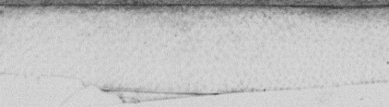

However, because of the visible A '**T**' view of a reused paste-down from

pages in front of the paste-down, many pages later (i.e. many pages after

I’d call this '**T**'. the paste-down). (part of image)

**[Classification c7,] "*T*iny background reuse""** (continued)

I’ve made a change based on what I think will give more positive finds (though perhaps only when asking the archive to look). This will affect both tiny background reuse and cover wraparound reuse, so I’m going to put a refer-here sign

**†** When only a sliver of the cover wrap-around is visible, *and* you can see ruling lines, it should be positive for tbr or cwa, depending on the case. Examples should help, though you’ll likely have to zoom unless (until) I get back in here to greenify stuff.

This will require going back to re-classify some stuff, but I think it’s worth it.

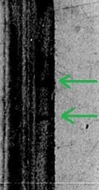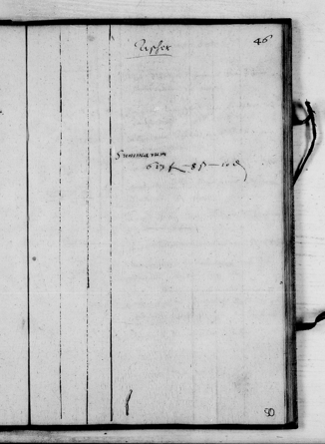***Note that this only goes for tiny background reuse and cover wraparound reuse. Any other classification base (i.e. front matter, outside cover, connecting/guard …) on which you see ruling lines but no text/decoration/illustration* *should be marked as negative for binding reuse.***

Should be a '**T**'.

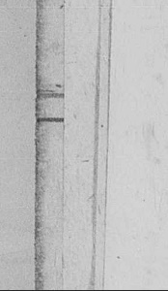

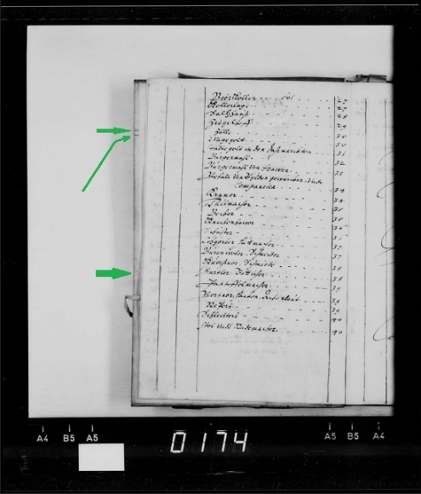 **FamilySearch_-_DGS008279839_00981**

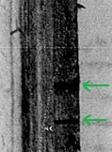

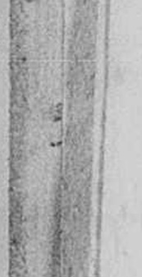

**FamilySearch_-_DGS008279840_00066**

BAD! NOT THIS ONE ↓, EITHER! NO!!!!

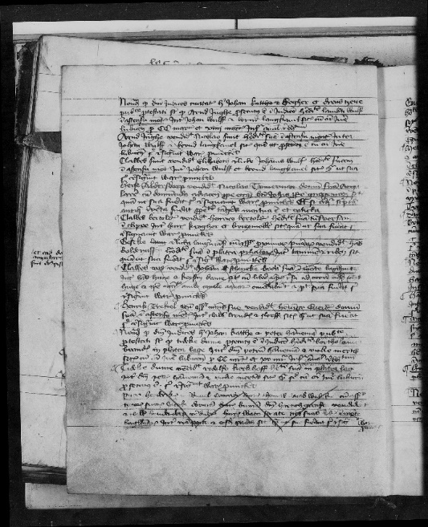 This one should be '**T**'.; I’d probably let a '**W**'

pass.

BAD, NOT THIS ONE ↓. NO!!!!

B

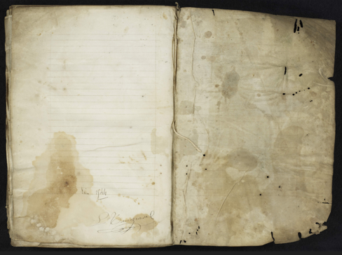 **KansasUniv_-_MSD47_00056** A

← D

B

A

D

→ ←

B

A

D

← ~~D~~

**FamilySearch_-_DGS008909919_00668**

There is ruling without words here, but we’re On this, you can see the ruling on a sliver, but it’s on

not on an accepted surface type.a folio in the middle of the codex.

**[Classification c8,] "*C*onnecting or guard reuse "**

<DisplayName> **Connecting or Guard Reuse** </DisplayName>

<KeyboardShortcut> **C** </KeyboardShortcut>

<DirectoryName> **Connecting_or_Guard_Reuse** </DirectoryName>

<AddedFilenameEnding> **scg** </AddedFilenameEnding>

This is often, but not always, small, so I took the “small” out of the name. The 's' in the three-letter directory ending will just stay there, I guess. ~~Just giving examples for now.~~ Oh, if unsure between this ('**C**') and '**T**', choose '**T**'. (I really like these.)

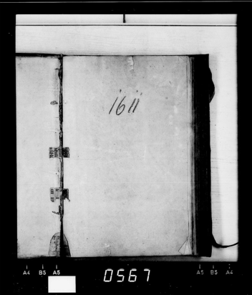 **????? (from e-codices)**

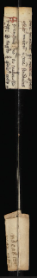

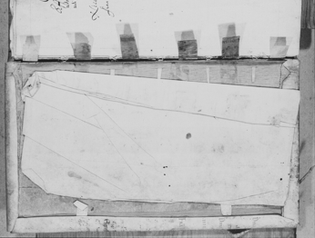**FamilySearch_-_DGS004534287_00172**

**????? FS**

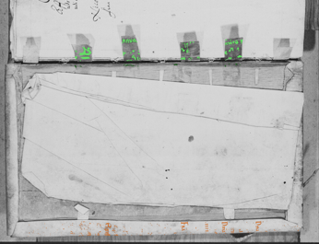

Mid-book (parts of 3

consecutive images)

My only guess for I really like these!

**Banitsa Gospels**

reuse below is

'**C**'.

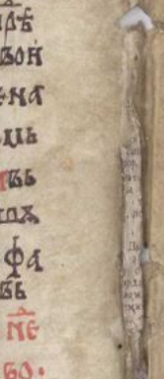

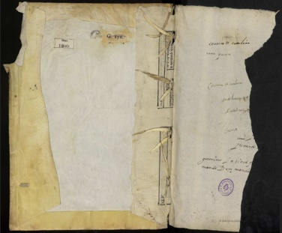 **LOC**

↑ Besides '**C**' (green) there is '**W**' (orange),

meaning we need to add '**B**' as well.

(part image, rotated CCW)

**LOC_-_** **BnE_-_CronicaCatalynya_Mss1880_00002**

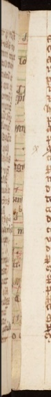**ComplutensianPolyglot**

**BibleVol3_** This ↑ is a good view of the connecting type of

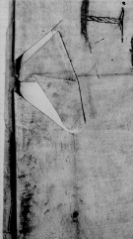**wdl-10636-003_00536** reuse. The straps which tie pages together connect to the

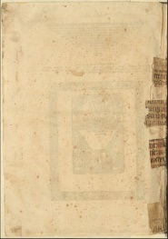 the cover by the reused (printed) writing surface.

**???????? FS**

**??????**

 I should really check with a

codicologist on this one…

(partial image) Can be found in the middle of books. (part, rotated CCW)

**[Classification c8,] "*C*onnecting or guard reuse "** (continued)

I’ve run into a new situation where only the spine part of the book has a piece that binds the folia together. See the examples below. Though these would be functionally better described as spine protection reuse, the visual characteristics are more like that of connecting or guard reuse, so they will be classified as '**B**'. An interesting note: these have only been found in documents from the Spanish Inquisition.

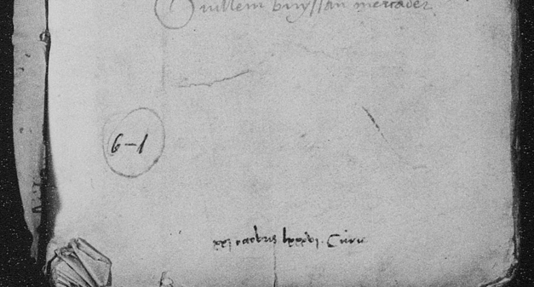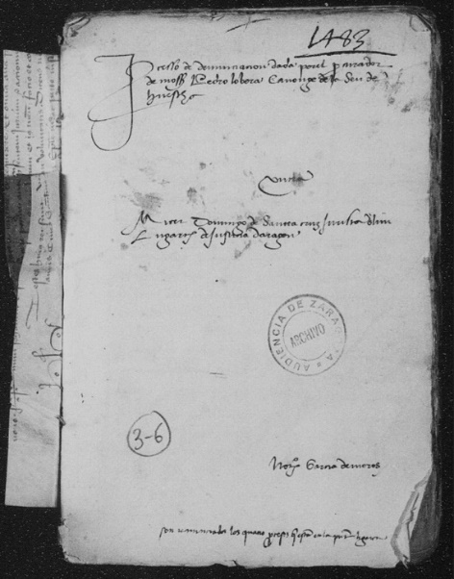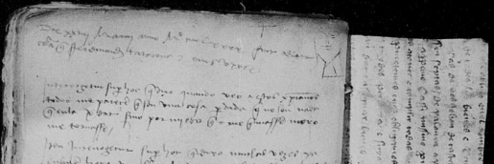

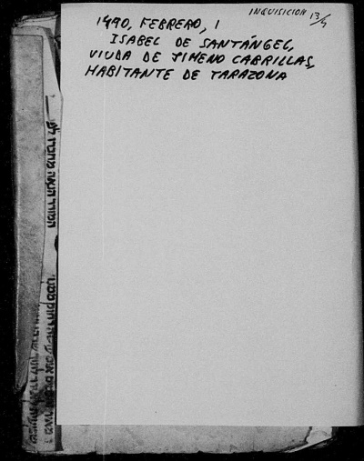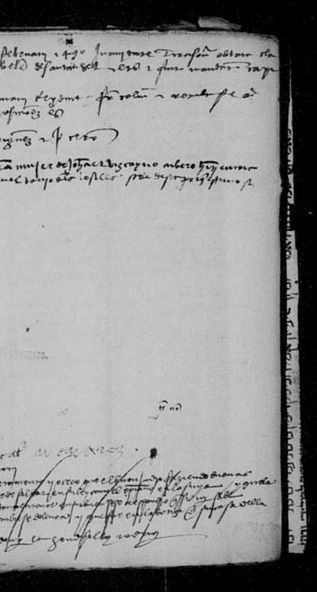

**FamilySearch**

**DGSs 008225062, 008224595,**

**[Classification c9,] "across book *G*utter reuse "**

<DisplayName> **across book Gutter reuse** </DisplayName>

<KeyboardShortcut> **G** </KeyboardShortcut>

<DirectoryName> **Across_Book_Gutter_Reuse** </DirectoryName>

<AddedFilenameEnding> **abg** </AddedFilenameEnding>

The book gutter is the place in between the two pages you can read without turning a page. This classification will only apply when the image is mainly showing the content of one page (one side of a folio). There will always be another classification used with '**G**', but the 'B' classification should only be used if there are two classifications other than '**G**'. This can happen if there is a different classification on the main page than that seen on the across-book-gutter page or if there are two classifications seen on the across-book-gutter page. If the only classifications seen on the main and across-book-gutter page are '**F**' (which is a frequent occurrence), '**B**' shouldn’t be used.

**LOC_-_MarcoPolo_gdcwdl-wdl-14300_00002**

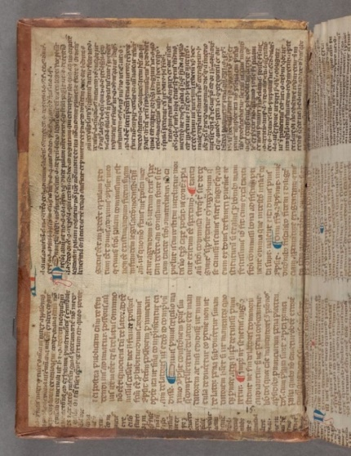

**Bodl_-_BodleianLib_MsLaudMisc417_00006**

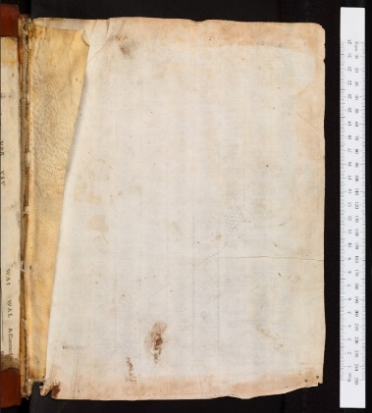

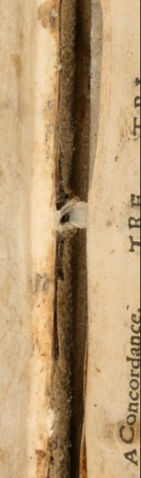

↑ '**G**' and '**F**' (but not '**B**') ↓ ↑'**G**' and '**F**' (but not '**B**'). What seems to be seen

thru the (front) flyleaf are marks visible on both sides

of a bunch-of-grapes watermark and the frame of the

paper-making box (a.k.a. ). Check out the fingerprints!

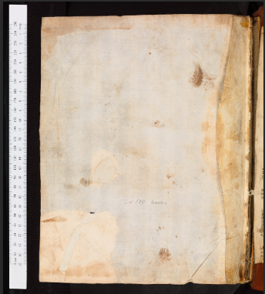

***REUSE OR OIC***

**Bodleian-Library-Douce-A-subt-67_00382**

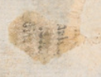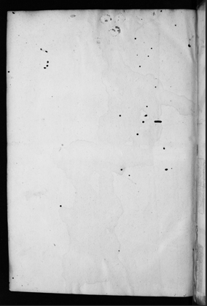

**Bodl_-_BodleianLib_MsLaudMisc417_00353**

The back-flyleaf of the same codex as above. '**G**','**F**','**R**' AND '**B**' (and watermark and fingerprints!)

'**G**' and '**F**' (but not '**B**')

**[Classification c10,] "wrapper reuse (*4*)"**

<DisplayName> **wrapper reuse (4)** </DisplayName>

<KeyboardShortcut> **4** </KeyboardShortcut>

<DirectoryName> **Wrapper_Reuse** </DirectoryName>

<AddedFilenameEnding> **wpr** </AddedFilenameEnding>

The definition of wrapper will be clarified in the captions to the examples. Basically, a limp-vellum binding without sewing – think of using wrapping paper to hold some papers, but without sewing or taping, more like a folder. The '**4**'

glyph is meant to evoke the folding of a wrapper, especially as would be done (into thirds) with our first example.

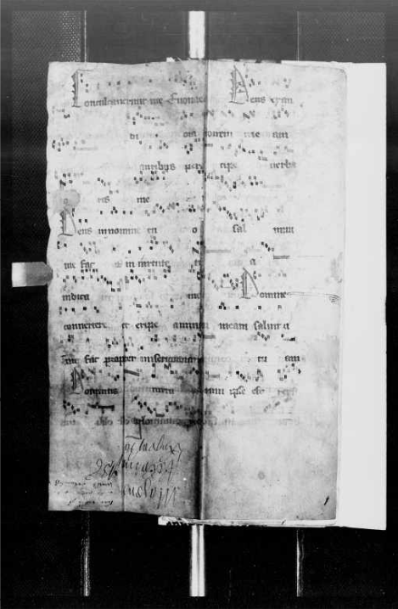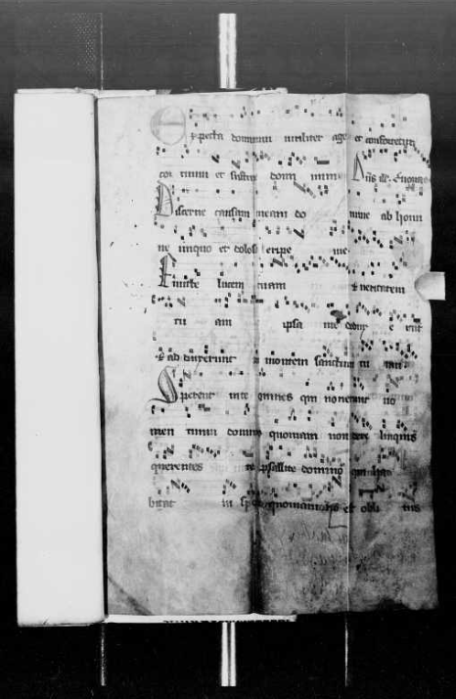

**FamilySearch_-_DGS004518368_00040**

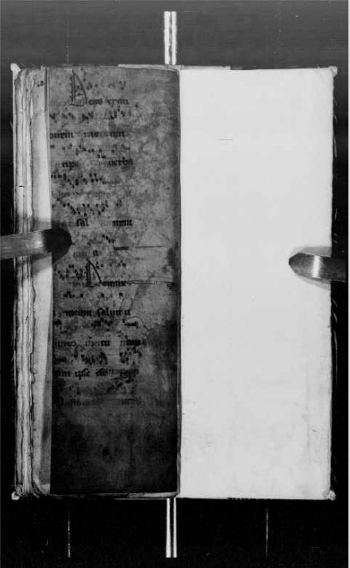

This is image 39. Note the *Dominus* with the long manicule (pointer finger) directed towards it, the same *Dominus* visible on image 40. Here, I can see that what I was calling W is actually not wraparound. However, this should not change the other classifications, since each image is to be classified as if no other outside information were known. '**4**','**F**', but not '**B**', because it’s the same piece of writing surface getting the '**4**'&'**F**' labels. (My executive decision)

This is image 38 in the DGS. None of the surface shown is visible on image 40 (the one to the left). However, the two folds leading to three (surrounding) protective surfaces are readily apparent. Label '**4**' and '**F**'. If it weren’t for (what I’m not thinking is actually) '**W**' but which I want the algorithm to identify as '**W**', we wouldn’t need a '**B**'. As things are, '**4**','**F**','**W**','**B**'.

This is a wrapper – almost like a folder holding other documents inside. The binding outside can throw one off, especially without any context. Even w/o context, the lack of any visible sewing would cause me to classify this as '**4**'. The new binding is now holding what the old wrapper used to hold. I can’t tell if the old wrapper is sewn into the new binding or simply inserted. (I suspect the former.) Either way, this same piece should receive '**F**'. Also note the '**W**' on the bottom of the new binding, or at least what I’d like the algorithm to classify as '**Wraparound reuse**'. Hopefully more clarity will come with the two images to the right of this one, which are two of the several images that precede this image in the repository. The image above is image 40 in the DGS. Also '**B**'

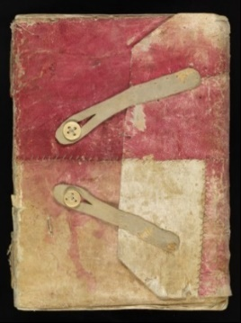

This is a wrapper WITHOUT REUSE on this surface, to help illustrate.

**St. Gallen, Stiftsbibliothek, Cod. Sang. 692**

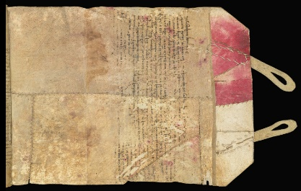

This is the same wrapper, partially unwrapped, and showing reuse. It helps show the concept of a wrapper, especially as you see the lack of sewing between the pages of the “bundle” and the wrapper. It gets '**4**','**F**','**B**'.

This is a wrapper, BUT WITHOUT REUSE. I just

**~~[Classification c11,] "not in situ reuse co~~*~~V~~*~~er"~~ Combined into c15 (Keyboard Y)**

<DisplayName> **not in situ reuse coVer** </DisplayName>

<KeyboardShortcut> **V** </KeyboardShortcut>

<DirectoryName> **Not_In_Situ_Reuse_Cover** </DirectoryName>

<AddedFilenameEnding> **nsc** </AddedFilenameEnding>

Blah, I know it, but not so well as I thought.

**BesanconBibMun_-_MS0716_00003**

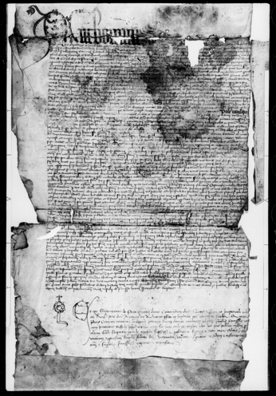

**FamiliySearch_-_DGS101886853_00951**

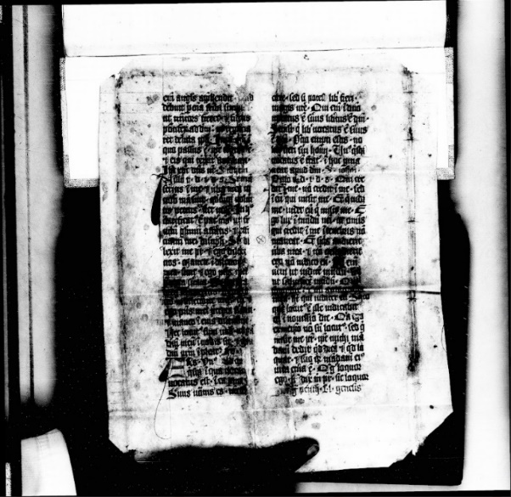

There’s one that looks really nicely like the brown-paper book covers we made at school.

**BaselStaatsarchBasel-Stadt_-_Fragmente-II-Klosterarchiv-St-Alban-DD-1_00002-f1v**

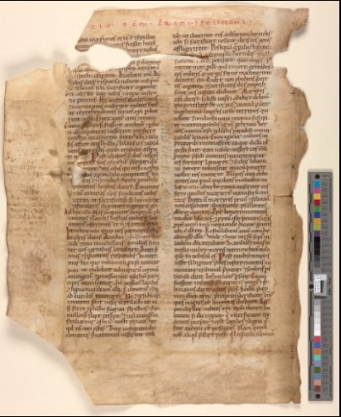

**NewberryLib_-_Case-Ms-Fragment-7-IIv-Ir**

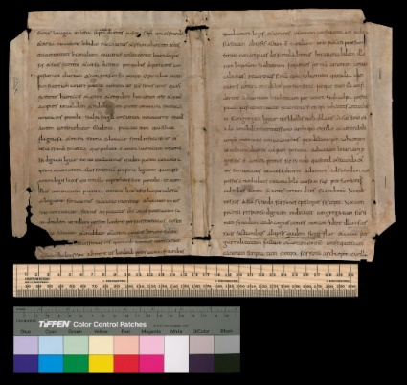

f

Front matter or cover (?) Title up middle (?)

Okay, Dave realizes he’s not specialized enough to know beans about differentiating this not-in-situ stuff. '**V**', '**A**', '**9**', and '**7**', will be combined for scoring. Pick <didn’t make a pick> for any/all of them, I don’t know why I picked that one. In fact, let’s just call '**Y**' general in-situ stuff, because I’m kind of saying “wh**Y**?!? (can’t I figure this out?)”.

**~~[Classification c12,] "not in situ reuse front-b~~*~~A~~*~~ck"~~ Combined into c15 (Keyboard Y)**

<DisplayName> **not in situ reuse front-bAck** </DisplayName>

<KeyboardShortcut> **A** </KeyboardShortcut>

<DirectoryName> **Not_In_Situ_Reuse_Front-back** </DirectoryName>

<AddedFilenameEnding> **nsf** </AddedFilenameEnding>

Blah, I know it, maybe …

**BernBurgerbib_-_Cod-756-70-8r-- CodicesRestituti_Cod-5-ecod_00001**

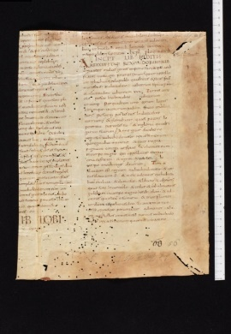

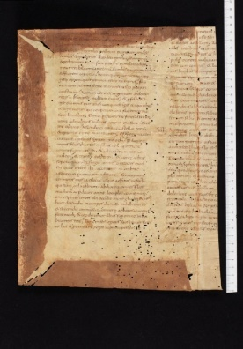

**SolothurnZentralbib_-_Cod-R-1.1.45-3--**

**CodicesRestituti_Cod-3-ecod_00013**

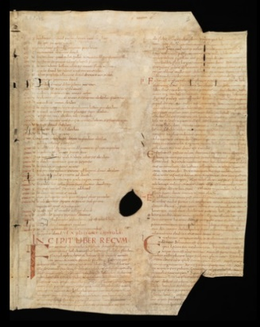

**BernBurgerbib_-_Cod-756-70-8v--CodicesRestituti_Cod-5-ecod_00002**

Two sides of what was a pastedown; more paste on the verso.

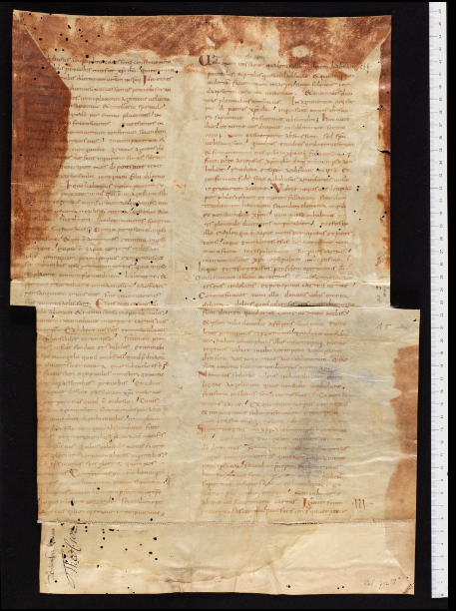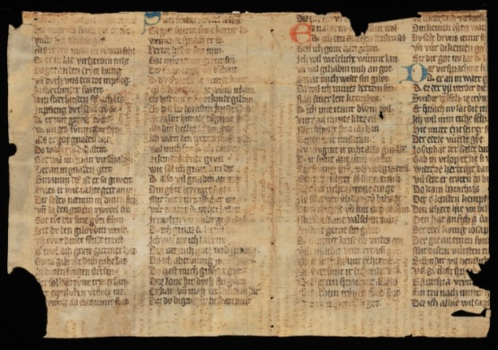Seems like front-matter to me, since you  
can see the places where the connecting  
and guard reuse came through from the  
gatherings of pages

**SchaffhausenStaatsarch_-_ Ems_fragment-3_00002**

They say this was a cover, I think it was some front-

back matter. They’re likely right, but I’m putting the **?????**

cool image here. (I might have been singing that to

myself.) This one shows how one original sheet (the reused sheet) can

be used for front matter at the beginning *and* end of a codex.

And it has some nice, yellow embroidery.

Okay, Dave realizes he’s not specialized enough to know beans about differentiating this not-in-situ stuff. '**V**', '**A**', '**9**', and '**7**', will be combined for scoring. Pick <didn’t make a pick> for any/all of them, I don’t know why I picked that one. In fact, let’s just call '**Y**' general in-situ stuff, because I’m kind of saying “wh**Y**?!? (can’t I figure this out?)”.

**~~[Classification c13,] "not in situ reuse spine protection (~~*~~9~~*~~)"~~ Combined into c15 (Keyboard Y)**

<DisplayName> **not in situ reuse spine protection (9)** </DisplayName>

<KeyboardShortcut> **9** </KeyboardShortcut>

<DirectoryName> **Not_In_Situ_Reuse_Spine_Protection** </DirectoryName>

<AddedFilenameEnding> **nsp** </AddedFilenameEnding>

Blah, I know it; wait, maybe not.

I don’t know how many of these there are going to be, and even if I did, I don’t know if I could ID them.

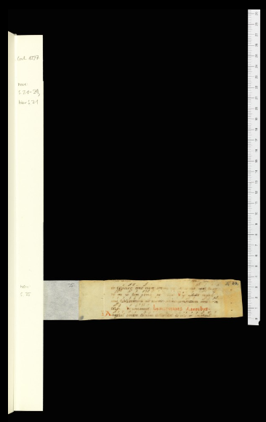

f

**?????**

Okay, Dave realizes he’s not specialized enough to know beans about differentiating this not-in-situ stuff. '**V**', '**A**', '**9**', and '**7**', will be combined for scoring. Pick <didn’t make a pick> for any/all of them, I don’t know why I picked that one. In fact, let’s just call '**Y**' general in-situ stuff, because I’m kind of saying “wh**Y**?!? (can’t I figure this out?)”.

**~~[Classification c14,] "not in situ reuse connecting guard (~~*~~7~~*~~)"~~ Combined into c15 (Keyboard Y)**

<DisplayName> **not in situ reuse connecting guard (7)** </DisplayName>

<KeyboardShortcut> **7** </KeyboardShortcut>

<DirectoryName> **Not_In_Situ_Reuse_Connecting_Guard** </DirectoryName>

<AddedFilenameEnding> **nst** </AddedFilenameEnding>

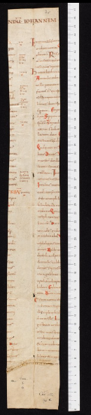Blah, I know it; well, I think so. Maybe not.

**SolothurnZentralbib_-_Cod-S-II-154.3-13--**

**CodicesRestituti_Cod-3-ecod_00020**

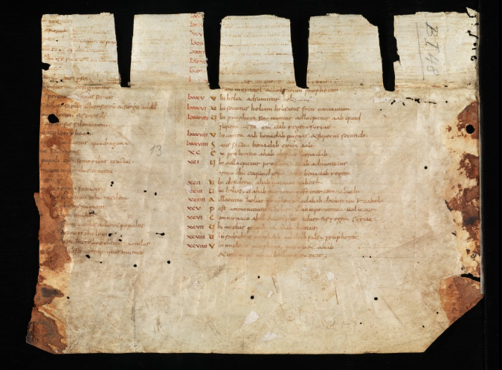

I think this tall, thin, drink of

water comes from the same

collection as that thing to the

left, but for now …

… **??????**

Some of the reuse

that you see in the

middle of the book,

and some nice,

yellow embroidery

Okay, Dave realizes he’s not specialized enough to know beans about differentiating this not-in-situ stuff. '**V**', '**A**', '**9**', and '**7**', will be combined for scoring. Pick <didn’t make a pick> for any/all of them, I don’t know why I picked that one. In fact, let’s just call '**Y**' general in-situ stuff, because I’m kind of saying “wh**Y**?!? (can’t I figure this out?)”.

Other classes to be used later in Manuscript Studies things

Possible number/Dir Name | three-letters

c50 / Stitching_Any_Type | stc  
Should later be moved into one of the following |

c51 / Stitching_Level_1 | st1  
(parchment maker, basic repairs with twine, |  
 no-longer-there veil stitch holes, |  
… anything else I think of) |

c52 / Stitching_Level_2 | st2  
 (beyond basic twine, hole stitch, not embroidery, |  
 baseball stitch, green Vs, |  
 … other things maybe) |

c53 / Stitching_Level_3_Embroidery_etc | st3  
 (Embroidery, in-place veils, other fancy, |  
 … and blah and blah and blah) |

c54 / Manicule | man

c55 / Non_Manicule_Nota_Bene | nmn

c56 / Fingerprint | fgp  
 (Has to have loops/whirls, or at least visual |  
 separation between the grooves |  
 … any other details) |

c57 / Hair_on_parchment | hop  
 (Meaning animal hair, like in the holes of the |  
 parchment, or even still looking like fur/wool |  
 on a used page) |

c58 / Very_Visible_Watermark | vvw

c59 / Not_For_Binding_Reuse | nfb

c60 / Iron_Gall_or_other_Corrosion_Thru | igt

c61 / Squished_Bug_Remains | sbr

Still thinking about

Portrait of Scribe

Portrait of Illustrator/Illuminator

Portrait of Parchment Maker

Portrait of Reader

Portrait of Binder

Portrait of Paper Maker (different ones, here)

Portrait of Printer

Line Drawing

Kinds of Clothes

Missing Initial/Illumination (Marked or Unmarked)

Parchment Animal Veins

Pop-ups, rotating thingies (there’s a technical term), etc.

Non-Commentary Marginal Notes

(Not quite same project, I think) abbreviations (let’s get completeness)

NSFW (some of those are pretty bawdry)

Hole Which Had Initial or Image Removed

Bookmarks – either the ones with string that can rotate or the ones sewn on edges

Difficult (?) Anything Left Inadvertently (Lost)

A Wolf Preaching to Sheep (I wanted to find this, once, but couldn’t find it)

Crucifixion Scene

Some study of bookworm, rat, etc. holes

Monk/scribe food in codex

Unique stuff not strained out of paper

Pressed flowers

Anything related to the pope being crossed out (supposedly common in English books around 1570+, but I haven’t found one, yet, as of 2025-05-06).

Crumpled pages put back in (Marks of frustration)

Other levels of iron gall (and other) corrosion from that one description. Need expert.

Palimpsests. Need expert.

Hiding defects with illustrations or creative text things.

OTHER IDEAS

Microfilm damage, Duct tape, Human hand (gloved, fuzzy-gloved {Bigfoot}, watch, ring), Page being turned (shutter open for too long and/or page turned too fast at wrong time, Roman numerals (different forms), Hindu / Arabic Numerals (early vs. late), Greek Numerals, Russian Numerals, etc. Charters in decorative MSS. Candle wax drops (definitely need expert). Drool from sleeping (definitely need expert). Hints of reuse that could be imaged with Macro X-ray fluorescence (MA-XRF) Multi-Spectral Imaging (MSI), other penetrative imaging – giving them some good ones to try on, whether the hints be small groups of ink-colored pixels in the structure of text OR some hint in the structure of the binding that is more likely to have possible-to-find-with-penetrative-imaging reuse (*definitely* need expert, even for some ground truth).

[Write others to put in these documents later]

Things to find for contrastive examples (named as ‘Important_as_Counter_Example’, because I couldn’t come up with the word, contrastive, though I knew that the word, differentiating, was wrong, when I was editing the classifier.param file). I think that quite a few of these will involve languages/scripts. I know I found some first pages with Latin where the reuse-as-paste-down was Greek, and such things will be good.

A mixed language-and-not example: I found some negative examples for binding reuse that have big Hebrew text and big film holes on the side; I don’t want the algorithm to think the large Hebrew characters or the big film holes are what characterize negative for binding reuse. Perhaps more importantly, I don’t want it to classify an instance of reuse that happens to be with large Hebrew text and/or big film holes as being non-reuse, just because no examples of positive-Hebrew-holes are in the dataset.

Big film holes visible.

Smaller images – find out usage for collections on reddit, Flickr (especially Yale’s), blogs, pholder, photographs from microfilm machine, phone pics of manuscripts (need to contact BYU’s, U of U’s libraries), pics of books with examples.

Scans of books with examples. Pics and scans of local library facsimiles.

[Write others to put in these documents later]

Possibly one-offs until later (usually things found discussed or imaged in books, sometimes found in images)

Early illustration showing shadow (need to figure out which audio-book)

Upside-down “brand” in after-Caxton-guy’s kid’s book from printing, now as reuse (need to find audio book)

Pop-up made out of reuse – find that one medical/anatomy book. Book is printed, pop-up is from MS

Interesting sociological/demographic, e.g. the lady’s Gilded (Manuscript) book talking about dark-skinned man.

[Write others to put in these documents later]